# Lecture 10

1. Find local maximum/minimum for function of 2 variables

Let $f(x,y)$ be a function with second-order derivatives exists. Then if we want to find its local maximum/minimum, we need to let $f_{x}=f_{y}=0$, and such point $\left(x_{0},y_{0}\right)$ satisfying $f_{x}=f_{y}=0$ is called a critical point.

However, we do not know whether a critical point is a max, min or neither. We need to look at second-order partial derivatives. Let $A=f_{xx}\left(x_{0},y_{0}\right), B=f_{xy}\left(x_{0},y_{0}\right), C=f_{yy}\left(x_{0},y_{0}\right).$ Then

$If AC-B^{2}>0 and A>0, then it^{'}s local minimum.$

$If AC-B^{2}>0 and A<0, then it^{'}s local maximum.$

$If AC-B^{2}<0, then it^{'}s a saddle.$

$If AC-B^{2}=0, then cannot conclude.$

1. Justification:

$$Δf≈f_{x}Δx+f_{y}Δy+\frac{1}{2}f_{xx}{\left(Δx\right)}^{2}+f_{xy}\left(Δx\right)\left(Δy\right)+\frac{1}{2}f_{yy}{\left(Δy\right)}^{2}$$

For critical points, $f_{x}=f_{y}=0,$ thus

$$Δf≈\frac{1}{2}f_{xx}{\left(Δx\right)}^{2}+f_{xy}\left(Δx\right)\left(Δy\right)+\frac{1}{2}f_{yy}{\left(Δy\right)}^{2}=\frac{1}{2}A{\left(Δx\right)}^{2}+B\left(Δx\right)\left(Δy\right)+\frac{1}{2}C{\left(Δy\right)}^{2}$$

$if at least one of A, C is not 0, due to symmetry assume A≠0, then$

$$Δf≈\frac{1}{2}A{\left(Δx+\frac{B}{A}Δy\right)}^{2}+\frac{1}{2}\frac{AC-B^{2}}{A}{\left(Δy\right)}^{2}$$

(a) When $AC-B^{2}>0,$ the 2 terms in $Δf$ have the same sign $(±)$, it is a local maximum or minimum. Thus if $AC-B^{2}>0$, it is minimum when $A>0$, and maximum when $A<0$.

(b) When $AC-B^{2}<0,$ the 2 terms in $Δf$ have the opposite sign, then it is a saddle.

(c) When $AC-B^{2}=0$, the $Δf≈\frac{1}{2}A{\left(Δx+\frac{B}{A}Δy\right)}^{2}$, it depends on sign of .

* 1. .

(a) If need to look at third order terms

(b) If $B≠0, AC-B^{2}<0$, it is a saddle

# Lecture 12

1. Gradient: $∇f=(f_{x}, f_{y}, f_{z})$
2. Tangent plane: on the tangent plane, $0=Δf≈f_{x}Δx+ f_{y}Δy+ f_{z}Δz .$ Therefore, tangent plane is $∇f\left(X_{0}\right)⋅\left(X-X_{0}\right)=0, where X_{0}=\left(x_{0}, y_{0}, z_{0}\right), X=\left(x,y,z\right).$
3. $∇f$ is the direction in which the value of f increases fastest.

Assume $\vec{u}=(a,b)$ is a unit vector, i.e., we can write the line in the direction of $\vec{u}$ as

$$\left\{\begin{aligned}x=x_{0}+as \\ y=y_{0}+bs\end{aligned}\right.$$

then the directional derivative is

$${\frac{df}{ds}}_{\vec{u}}=\frac{∂f}{∂x}⋅\frac{∂x}{∂s}+\frac{∂f}{∂y}⋅\frac{∂y}{∂s}=∇f⋅ \vec{u}=\left|∇f\right|⋅\left|\vec{u}\right|⋅\cos{θ}$$

When $\cos{θ}=1$, i.e., $∇f$ and $\vec{u}$ are towards the same direction, the directional derivative is maximized.

# Lecture 17 Double Integrals

1. Double integrals
$$\int{\int_{R}{f\left(x,y\right)dA}}$$

$dA=dxdy$

2. Polar system: $dA=rdrdθ$

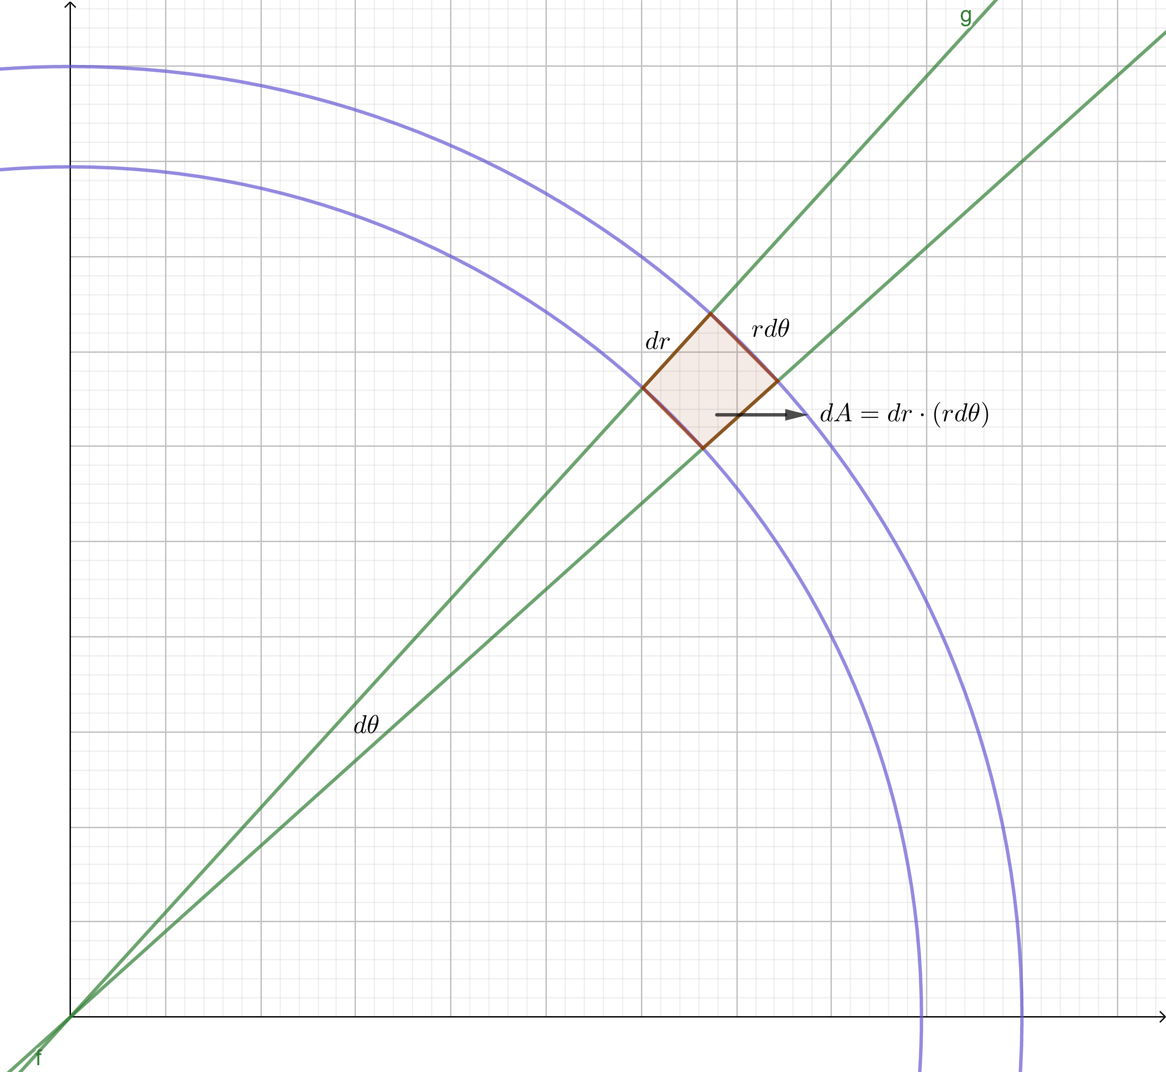

# Lecture 18 Change of Variables in Double Integrals

1. Calculate the volume of the ellipse $\frac{x^{2}}{a^{2}}+\frac{y^{2}}{b^{2}}=1$

$$Area=\int{\int_{ \frac{x^{2}}{a^{2}}+\frac{y^{2}}{b^{2}}≤1}{dA}}=\int{\int_{ \frac{x^{2}}{a^{2}}+\frac{y^{2}}{b^{2}}≤1}{dxdy}}$$

Let $u=\frac{x}{a}, v=\frac{y}{b},$ then $dx=d\left(au\right)=adu, dy=d\left(bv\right)=bdv,$

$$Area=\int{\int_{ \frac{x^{2}}{a^{2}}+\frac{y^{2}}{b^{2}}≤1}{dxdy}}=\int{\int_{ u^{2}+v^{2}≤1}{abdudv}}=πab$$

1. If $\left\{\begin{aligned}u=3x-2y \\ v=x+y\end{aligned}\right.$, then how do we compare $dudv$ and $dxdy$?

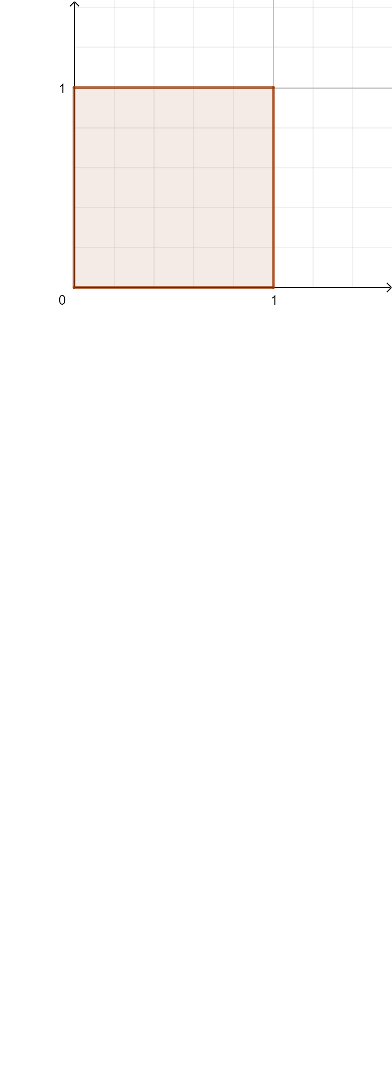

$$for x,y, A=1$$

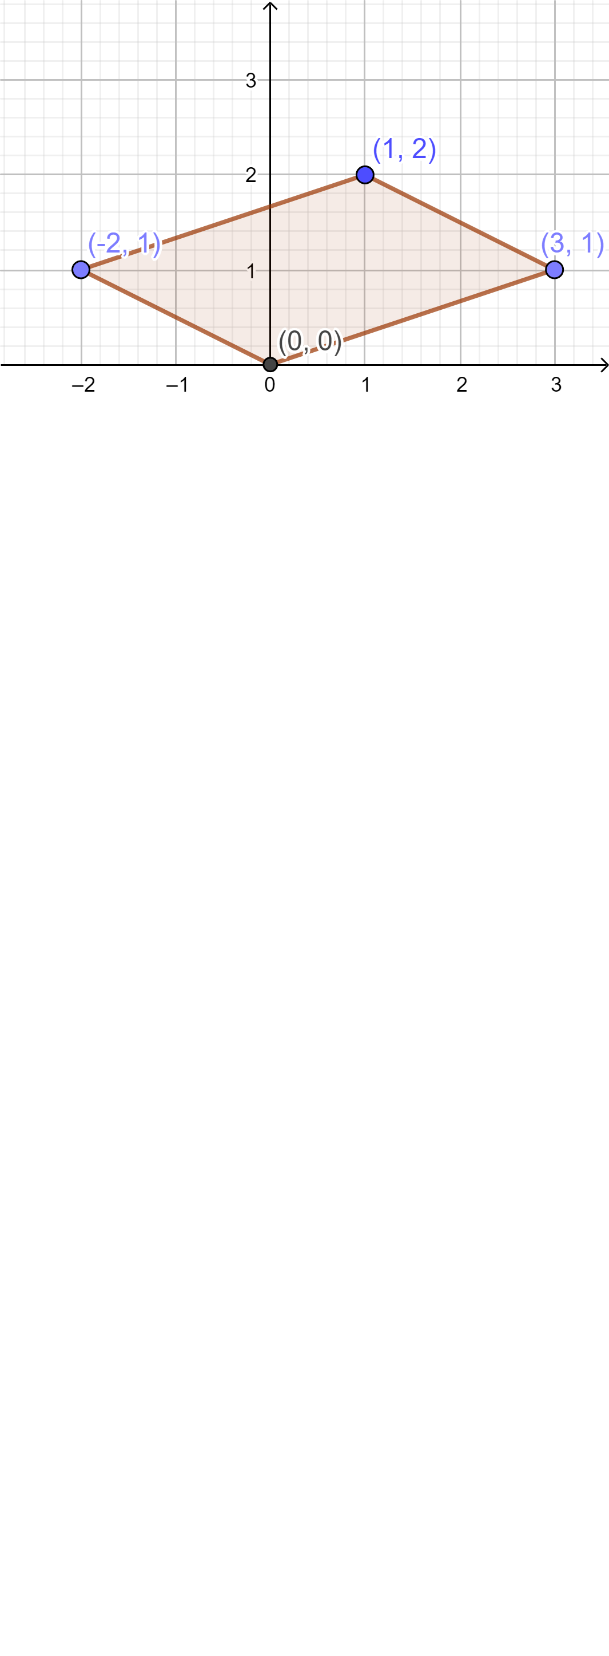

$$for u,v, A^{'}=\left|\begin{matrix}3 & -2 \\ 1 & 1\end{matrix}\right|=5$$

$$Therefore, we can infer dudv=5dxdy$$

Generally, if $\left[\begin{matrix}u \\ v\end{matrix}\right]=M\left[\begin{matrix}x \\ y\end{matrix}\right]$ for some matrix $M$, then $dudv=\left|det⁡(M)\right|dxdy$

1. If $u=u\left(x,y\right), v=v\left(x,y\right), then$

$$\left\{\begin{aligned}Δu≈u_{x}Δx+u_{y}Δy \\ Δv≈v_{x}Δx+v_{y}Δy\end{aligned} \right.$$

Then we have

$$dudv=\left|\left|\begin{matrix}u_{x} & u_{y} \\ v_{x} & v_{y}\end{matrix}\right|\right|dxdy$$

Define Jacobian

$$J=\frac{∂(u,v)}{∂(x,y)}=\left|\begin{matrix}u_{x} & u_{y} \\ v_{x} & v_{y}\end{matrix}\right|$$

$$Then dudv=\left|J\right|dxdy$$

We need the absolute value because area is non-negative.

1. Example: Evaluate $\int_{0}^{1}{\int_{0}^{1}{x^{2}ydxdy}}$, with change of variables $u=x, v=xy$

Method 1

Step 1: determine Jacobian

$$J=\left|\begin{matrix}1 & 0 \\ y & x\end{matrix}\right|=x→dudv=\left|J\right|dxdy=xdxdy$$

Step 2: determine the integrand

$$x^{2}ydxdy=\frac{x^{2}y}{x}dudv=xydudv=vdudv$$

Step 3: determine the integral range

$$\int_{0}^{1}{\int_{0}^{1}{x^{2}ydxdy}}=\int_{a}^{b}{\int_{c}^{d}{x^{2}ydudv}}$$

First determine the inner range $c and d$. For the inner range, we keep $v=xy$ as a constant. Then $\left(x,y\right)$ is on a hyperbola $xy=1$, and inside the square $x,y∈\left[0,1\right].$ The range of $u=x$ is $[v,1]$. Thus $c=v,d=1$

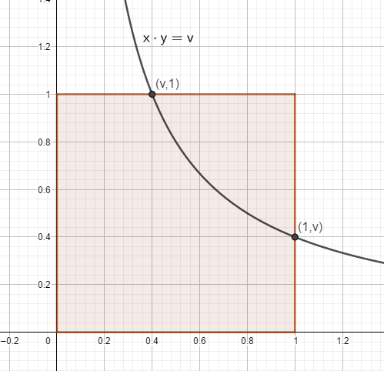

The range of $v=xy$ is the range of $xy$ inside the unit square and should be $[0,1]$.

Therefore $$\int_{0}^{1}{\int_{0}^{1}{x^{2}ydxdy}}=\int_{0}^{1}{\int_{v}^{1}{x^{2}ydudv}}$$

Method 2:

Step 1 and 2 are the same as method 1.

Step 3: The boundaries for $x,y$ are: $x=0, y=0, x=1, y=1.$

As $u=x, v=xy,$ we have:

$$x=0→u=v=0$$

$$y=0→v=0$$

$$x=1→u=1$$

$$y=1→u=v$$

Therefore, the integration range becomes:

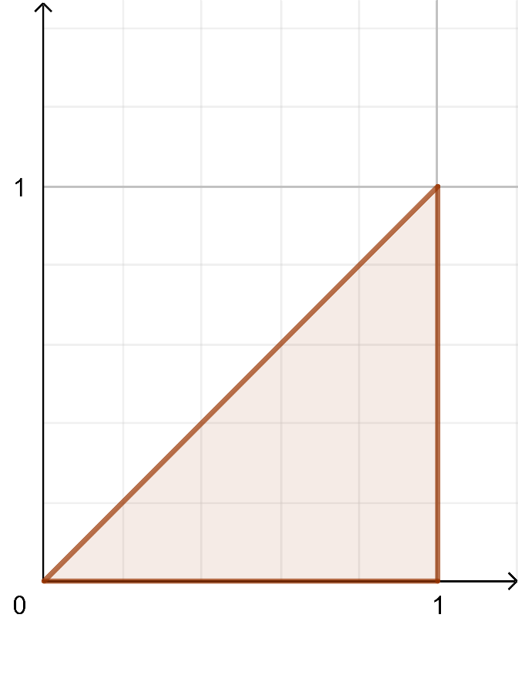

# Lecture19 Line Integrals

1. Line integral: $\int{\vec{F}}d\vec{r}$, where both $\vec{F}$ and $\vec{r}$ are vectors.

$$If we denote \vec{F}=<M\left(x,y\right),N\left(x,y\right)>, \vec{r}=<x,y>, then$$

$$\int{\vec{F}}d\vec{r}=\int{\vec{F}}\frac{d\vec{r}}{dt}dt =\int{\vec{F}}<\frac{dx}{dt},\frac{dy}{dt}>dt$$

$$\int{\vec{F}}d\vec{r}=\int{<M,N><dx,dy>}=\int{Mdx+Ndy}$$

We cannot calculate something like $∫f\left(x\right)dy$, so we must find some relationship between $x$ and $y$, e.g., express as $x=x\left(t\right),y=y(t)$, then

$$\int{\vec{F}}d\vec{r}=\int{Mdx+Ndy}=\int{Mx^{'}dt+Ny^{'}dt}$$

Also note that

$$\int{\vec{F}}d\vec{r}=\int{Mx^{'}dt+Ny^{'}dt}=\int{<M,N>}⋅<x^{'},y^{'}>dt=\int{\vec{F}}⋅\frac{\vec{dr}}{dt}dt$$

1. Geometry way
$$d\vec{r}=\vec{T}ds, where \vec{T} is the unit vector in the direction of \vec{r}$$

2. Different notation of line integral

$$d\vec{r}=\vec{T}ds=<dx,dy>$$

$$ds=\sqrt{1+{\left(y^{'}\right)}^{2}}dx=\sqrt{x^{'}{\left(t\right)}^{2}+y^{'}{\left(t\right)}^{2}}dt$$

# Lecture 20-21 Conservative Field and Gradient Field

1. Fundamental theorem of calculus for line integrals:

$$\int_{C}{∇f⋅}d\vec{r}=f\left(P_{1}\right)-f(P_{0})$$

Proof:

$$\int_{C}{∇f⋅}d\vec{r}=\int_{C}{f_{x}dx+f_{y}dy}=\int_{C}{\left(f_{x}⋅\frac{dx}{dt}+f_{y}⋅\frac{dy}{dt}\right)dt}=\int_{t_{0}}^{t_{1}}{\frac{df}{dt}dt=f\left(P_{1}\right)-f(P_{0})}$$

1. $\vec{F}=∇f$ is called a conservative field, and it is path independent.
2. Three equivalent properties:
   1. $\vec{F}$ is conservative
   2. $\int_{C}{\vec{F}⋅}d\vec{r}$ is path independent
   3. $\vec{F}$ is a gradient field
   4. $Mdx+Ndy$ is an exact differential $df$
3. If $\vec{F}=<M,N>$ is defined and differentiable everywhere, and $M_{y}=N_{x}$, then $\vec{F}$ is a gradient field.

$curl\left(\vec{F}\right)=N_{x}-M_{y}$

# Lecture 22 Green’s Theorem

$If C$ is a closed curve, enclosing a region $R,$ counterclockwise, and $\vec{F} i$ s a vector field defined & differentiable in R, then

$$\oint_{C}{\vec{F}}d\vec{r}=\iint_{R}{curl\left(\vec{F}\right)}dA$$

$$\oint_{C}{Mdx+Ndy}=\iint_{R}{\left(N_{x}-M_{y}\right)dA}$$

(Notice: R should be a simple connected region)

Proof: $if curl\left(\vec{F}\right)=0, then \vec{F}$ is a gradient field and $\oint_{C}{\vec{F}}d\vec{r}=0$.

Then we can assume N=0.

Cut $R$ into vertical simple pieces, and both sides of the equation equal of the sum of small pieces, so we only need to prove for small pieces.

The small pieces, with vertical sides, are easy to prove.

# Lecture 23 Flux

$If C$ is a closed curve, enclosing a region $R,$ counterclockwise, and $\vec{F} i$ s a vector field defined & differentiable in R, then the flux of $\vec{F}$ is

$$\oint_{C}{\vec{F}}\hat{n}ds$$

where $\hat{n}$ is the normal (perpendicular) unit vector along $C$, specifically, we rotate the tangent direction $\hat{T}$ 90 degrees clockwise to get $\hat{n}$, and $\hat{n}ds=<dy, -dx>$

If $\vec{F}=<P,Q>$, then $$\oint_{C}{\vec{F}}\hat{n}ds=\oint_{C}{-Qdx+Pdy}=\iint_{R}{\left(P_{x}+Q_{y}\right)dA}$$

Comparison with work:

* Work in line integral along the curve, while flux is line integral perpendicular to the curve.

$d\vec{r}=\vec{T}ds=<dx,dy>$

$\hat{n}ds=<dy, -dx>$

# Lecture 25-26

1. Cylindrical coordinates
$$\left\{\begin{aligned}x=r\cos{θ} \\ y=r\sin{θ} \\ z=z\end{aligned}\right.→dV=rdrdθdz$$

2. Spherical coordinates

$$\left\{\begin{aligned}z=ρ\cos{ϕ} \\ r=ρ\sin{ϕ} \\ θ=θ\end{aligned}\right.$$

$$\left\{\begin{aligned}x=ρ\sin{ϕ}\cos{θ} \\ y=ρ\sin{ϕ}\sin{θ} \\ z=ρ\cos{ϕ}\end{aligned}\right.$$

$$dV=ρ^{2}\sin{ϕ}dρdθdϕ$$